# **BigQuery: Qwik Start – Console**

Open BigQuery

The BigQuery console provides an interface to query tables, including [public datasets](https://cloud.google.com/bigquery/public-data) offered by BigQuery. The query you will run accesses a table from a public dataset that BigQuery provides. It uses standard query language to search the dataset, and limits the results returned to 10.

Open the BigQuery console

1. In the Google Cloud Console, select **Navigation menu** > **BigQuery**.

The **Welcome to BigQuery in the Cloud Console** message box opens. This message box provides a link to the quickstart guide and the release notes.

1. Click **Done**.

The BigQuery console opens.

Query a public dataset

1. Copy and paste the following query into the BigQuery Query editor:

#standardSQL

SELECT

weight_pounds, state, year, gestation_weeks

FROM

`bigquery-public-data.samples.natality`

ORDER BY weight_pounds DESC LIMIT 10;

This data sample holds information about US natality (birth rates).

A green or red check displays depending on whether the query is valid or invalid. If the query is valid, the validator also describes the amount of data to be processed after you run the query.

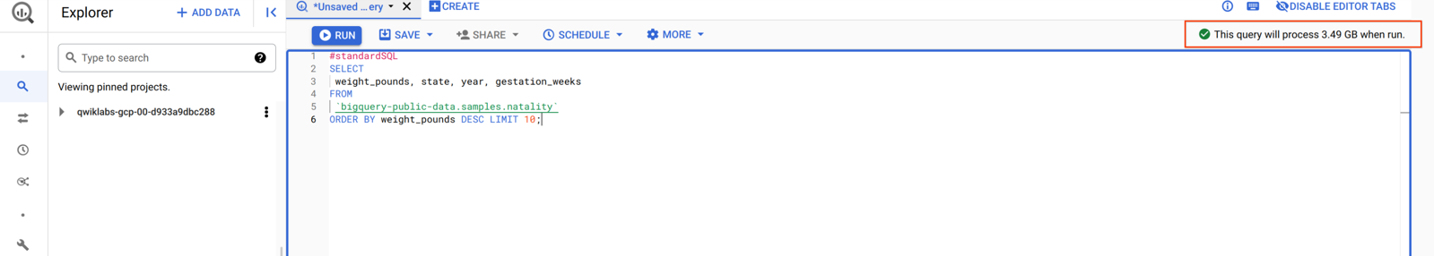

This information helps determine the cost to run a query.

1. Click the **Run** button.

Your query results should resemble the following:

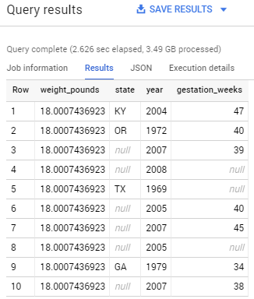

You can browse the schema of other public datasets in BigQuery by clicking **+ ADD DATA** > **Explore public datasets**, then search for "bigquery public data" in the Search field.

Load custom data into a table

To load custom data into a table, you perform the following tasks:

* Create a dataset
* Create a table
* Add data to your project (to a storage bucket)
* Load the data from the bucket to the table you created

Create a dataset

Datasets help control access to tables and views in a project. This lab uses only one table, but you still need a dataset to hold the table.

1. In the left pane, near your project id click on **view actions** then click **Create Dataset** in the **Explorer** section.

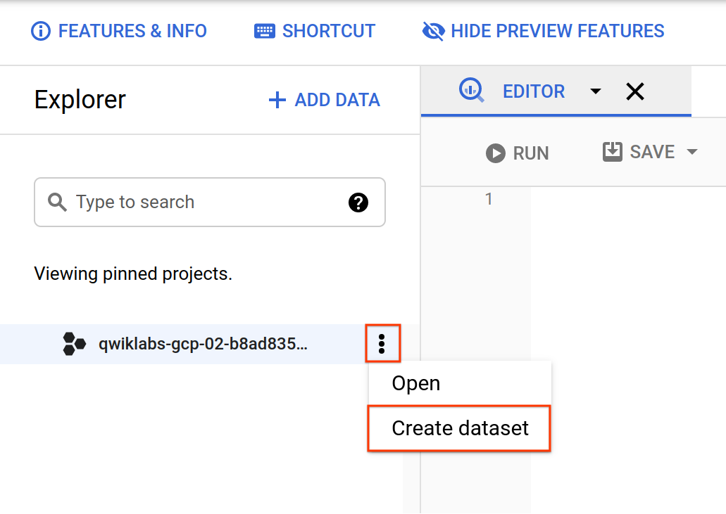

1. Set **Dataset ID** to **babynames**.
2. Leave all other fields at their default settings. Click **Create dataset**.

Now you have a dataset.

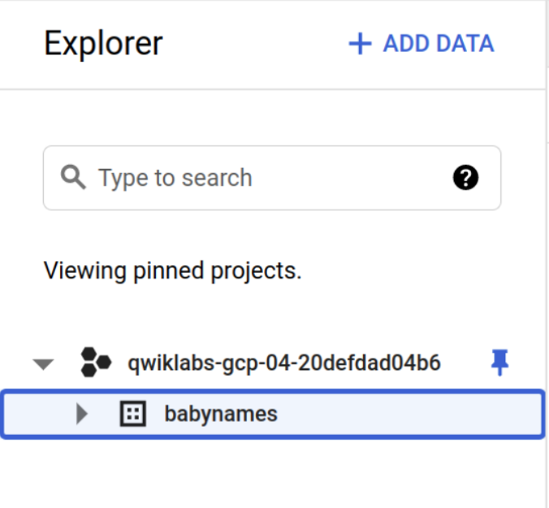

**Add custom data**

The custom data file you'll use contains approximately 7 MB of data about popular baby names, provided by the US Social Security Administration. You'll add the zip file to your project then create a storage bucket for the specific file that you'll need to query against.

In Cloud Shell, run the following commands to add the data files to your project:

gsutil cp gs://spls/gsp072/baby-names.zip .

unzip baby-names.zip

**Create a Cloud Storage bucket**

Now create a Cloud Storage bucket to hold the data files you downloaded.

1. In the Cloud Console, select **Navigation menu** > **Cloud Storage** > **Browser**, and then click **Create bucket**.

**Note**: If prompted, Click **LEAVE** for Unsaved work.

1. Give your bucket a [universally unique name](https://cloud.google.com/storage/docs/naming), then click **Create**.
2. In Cloud Shell, run the following to move file yob2014.txt into your bucket. Replace <your_bucket> with the name of the bucket you just created:

gsutil cp yob2014.txt gs://<your_bucket>

Now you can tell BigQuery where to find the data to query against.

**Load the data into a new table**

Next you create a table inside the babynames dataset, then load the data file from your storage bucket into the new table.

1. In the Cloud Console, select **Navigation menu** > **BigQuery** to return to the BigQuery console.
2. Navigate to the **babynames** dataset, by clicking **view actions** near your dataset then click **Create table**.

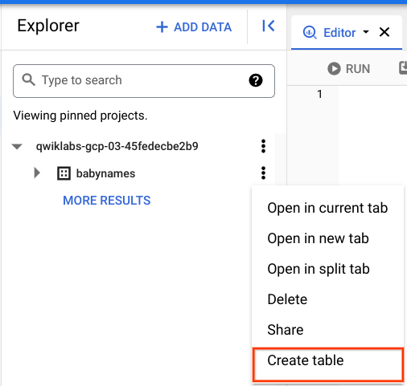

1. In the Create table dialog, set the following fields, leave all others at the default value:

|  |  |
| --- | --- |
| **Field** | **Value** |
| Create table from: | **Google Cloud Storage** |
| Select file from GCS bucket: | <bucket_name>/yob2014.txt, replace <bucket_name> with the name of the bucket you created earlier. |
| File format: | **CSV** |
| Table | names_2014 |
| **Schema** > Edit as text | Slide on, then add the following in the textbox: name:string,gender:string,count:integer |

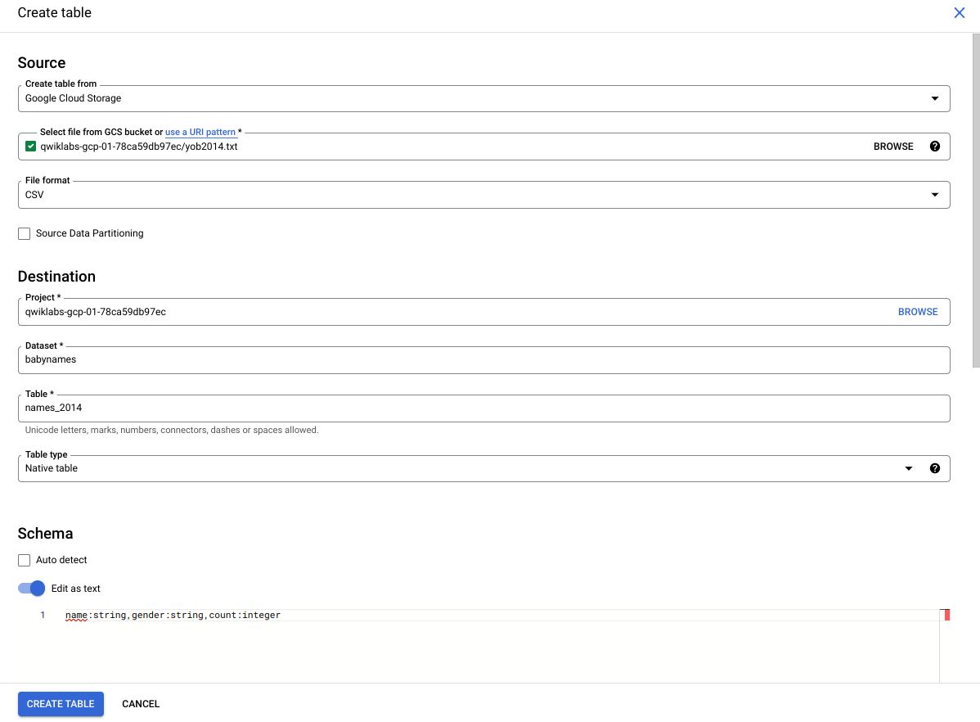

1. Click the **Create Table** button.

When BigQuery is finished creating the table and loading the data, you see the names_2014 table under the babynames dataset.

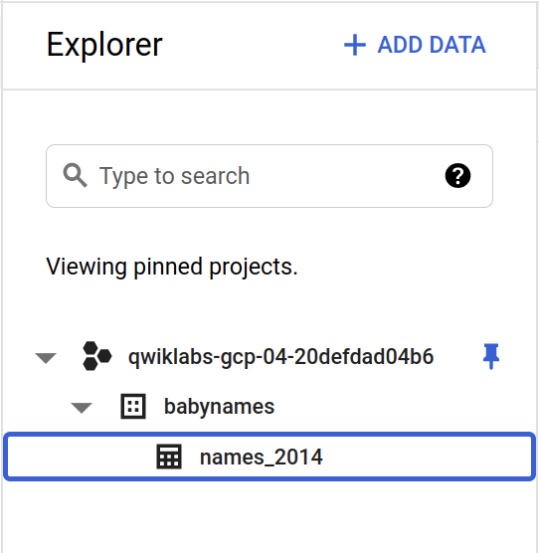

**Preview the table**

Check your table! View the first few rows of the data.

Click the names_2014 table in the left-hand menu, then click **Preview**.

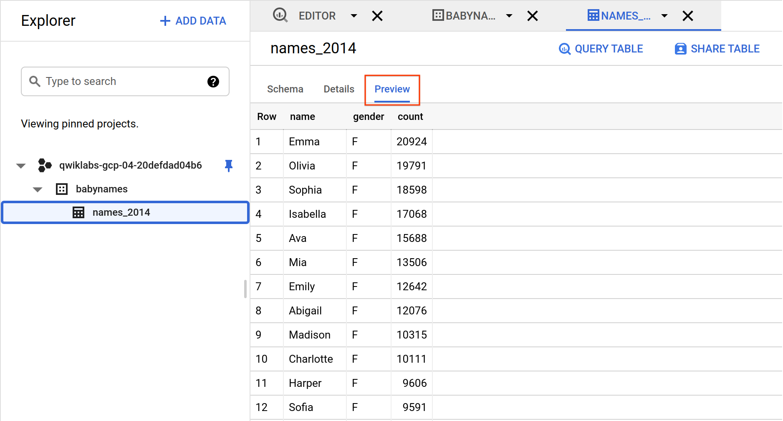

Your table is ready for queries.

**Query a custom dataset**

Running a query against custom data is identical to [querying a public dataset](https://cloud.google.com/bigquery/quickstart-web-ui#query_a_public_dataset) that you did earlier, except that now you're querying your own table instead of a public table.

In BigQuery, click the **+Compose new query** button at the top.

Paste or type the following query into the **Query editor**.

**Note**: If your table name is something other than **babynames**, update the code with your table name.

#standardSQL

SELECT

name, count

FROM

`babynames.names_2014`

WHERE

gender = 'M'

ORDER BY count DESC LIMIT 5;

Click the **Run** button. The query displays the top 5 boys names for the year of data (2014) you loaded into the table.